**Reconfiguring the ASEAN Framework: General Equilibrium Impact of Australia's Inclusion and India's Exclusion - A Structural Gravity Model Analysis**

**ECO412A : International Economics and Finance**

Debashree Priya Sahoo

Student, Department of Economic Sciences, IIT Kanpur

**Abstract**

*This paper investigates the potential impact on the ASEAN trade bloc resulting from Australia's inclusion and India's exclusion, using a structural gravity model. ASEAN, a significant regional trade association in Southeast Asia, is known for its dynamic and multifaceted trade relationships, both internally among member countries and externally with major global economies. The study explores how the hypothetical changes in the bloc's composition would affect these intricate trade patterns. By analyzing the shift from the ASEAN-India Free Trade Area (AIFTA) to a potential ASEAN-Australia FTA (AAFTA), the research provides insights into the general equilibrium effects on trade flows within ASEAN and its key trade partners. This paper seeks to identify which counterfactual setup is more effective based on empirical data and the general equilibrium results, aiming to shed light on their economic relevance. This approach provides a new perspective to view the economic dynamics within ASEAN, offering valuable insights for policymakers and economic strategists as they navigate the potential future shifts in this region's trade landscape.*

**Keywords**- *Structural Gravity Model, ASEAN Trade Bloc, Counterfactual Scenarios, Multilateral Resistance , PPML, General Equilibrium*

1. **Introduction**

The global landscape of the 21st century is intricately intertwined by the exchange of goods and services across national borders. International trade has become a fundamental pillar for economic advancement and well-being, acting as a driver for progress, innovation, and intercultural dialogue. In this context, international trade agreements play a pivotal part. They provide a systematic structure for nations by reducing trade barriers, expanding market reach, and fostering equitable competition. This organized framework helps countries to leverage their unique strengths, broaden their economic base, and work toward long-term prosperity.

One of the key regional alliances promoting economic integration is the **Association of Southeast Asian Nations (ASEAN)**. ASEAN consists of ten countries: Indonesia, Malaysia, Philippines, Singapore, Thailand, Brunei, Vietnam, Laos, Myanmar, and Cambodia. As India has become a strategic partner of ASEAN, so 11 countries will be considered (10+India) This group represents a rich tapestry of economies, including countries with abundant natural resources, manufacturing powerhouses, and emerging technology hubs.This group is a major player in the world economy and holds a strategic position that connects Eastern and Western markets. Despite their differences, these member nations are united by a shared vision for peace, stability, and mutual economic growth.

India's relationship with ASEAN has evolved from a Sectoral Partner in 1992 to a Strategic Partnership in 2012, reflecting growing diplomatic and economic ties. India ranks as ASEAN's seventh-largest trading partner, while ASEAN stands as India's fourth-largest trading partner. They share a robust and diverse partnership, ranging from trade and security to cultural exchanges, all underpinned by strategic agreements like AIFTA and RCEP. This alliance is instrumental in fostering regional peace, stability, and economic growth in the Asia-Pacific region.

Given its significance, understanding trade dynamics within ASEAN is critical for effective policymaking. Yet, in the ever-evolving global trade landscape, ongoing evaluation of such agreements and exploration of hypothetical scenarios is paramount. One intriguing scenario involves reconfiguring the ASEAN bloc by potentially including Australia and removing India. With their robust economy, technological prowess, and geographical proximity to Southeast Asia, Australia and India present a compelling subject for counterfactual analysis. While Australia's robust economy and geographical proximity to Southeast Asia make it a compelling addition, India's exclusion could potentially disrupt established trade patterns and strategic alliances within the bloc. This analysis involves gathering detailed data on exports, tariffs, and other trade-related factors from these countries and arrive at the general equilibrium effects of the reconfiguration in trade agreement.

The question arises: could Australia's integration and India's exit amplify the bloc's economic influence, or might it introduce new dynamics and challenges to the existing synergy?

1. **Objective and Significance**

The principal aim of this research is to employ a structural gravity model to examine the general equilibrium effects of potential changes in the ASEAN Trade Agreement on bilateral trade among its member countries. This objective entails a multifaceted analysis that encompasses several key aspects. First it seeks to understand how successful the trade agreement has been in fostering bilateral trade and economic growth among these countries. The analysis involves gathering data on country-specific exports, tariffs, border policies, and other pertinent economic variables.

Additionally the research will employ counterfactual analysis to model alternative trade scenarios, focusing on Australia's inclusion and India's departure from the ASEAN trade bloc. This will allow us to gauge the impact on trade dynamics within the bloc. The research will also extend its scope to include **five** significant non-member countries that maintain robust trade relations with both Australia and India. This broader analysis aims to evaluate the general equilibrium effects of such ASEAN reconfigurations on these non-member states. The study will also explore the implications for trade patterns and economic stability among both ASEAN members and these non-member countries, particularly in the context of the transition from the AIFTA to the AAFTA trade agreement, reflecting Australia's entry and India's exit. And compare the results to check which nation is more efficient, that is India or Australia.

ASEAN member countries have a history of political tensions, and the trade agreement serves as a platform for dialogue and cooperation. By promoting economic interdependence, it contributes to regional stability and peace. ASEAN countries can diversify their export markets, reducing reliance on a single trading partner. This diversification enhances resilience to economic shocks. The research will help in gauging the overall economic welfare effects of the ASEAN Trade Agreement, providing critical information for both member and non-member states. Valuable insights through the findings are provided to the policymakers within the ASEAN region and beyond.

1. **Literature Review**

This literature review encapsulates previous scholarly works that have employed the gravity model to assess the impacts of trade agreements on the movement of goods and services. Although the gravity model lacks strong theoretical support, it has proven effective in practical research. These studies have revealed varying results. Some studies have uncovered the Trade Creation (TC) effect, signifying enhanced trade among agreement members, while others have illuminated the Trade Diversion (TD) effect, indicating a shift away from non-member trade partners. The pivotal point of distinction lies in the balance between TC and TD effects. If the TC effect outweighs that of TD, it signifies that the free trade agreement (FTA) has succeeded in bolstering a nation's welfare and economic well-being.

Foundational to this area of study are the contributions of Bergstrand, who in 1985 and 1989 laid down the fundamental principles of the gravity model, taking into account economic factors in both exporting and importing countries and various factors influencing bilateral trade. Tinbergen, in 1962, was a pioneer in introducing the gravity equation in trade studies, establishing a direct correlation between the trade volume of a pair of countries and their GDPs, and an inverse relationship with trade-related costs such as distance.

Further contributions include McCallum's 1995 study, which used the gravity model to explore the "Border puzzle" in U.S.-Canada trade, highlighting significant internal trade flows within Canada despite a Free Trade Agreement with the U.S. Eaton and Kortum in 2002 connected trade volume with barriers related to technology and geography. In 2003, Anderson and Wincoop introduced the "structural" gravity model, incorporating Multilateral Trade Resistance terms, thereby addressing several estimation issues prevalent in traditional models.

Chaney and Helpman, in 2008, added a layer of complexity to the model by including firm productivity heterogeneity in gravity-like equations. Francis in 2011 noted a shift in India's trade towards Asian developing nations and raised concerns about the negative trade balance with ASEAN-10, highlighting the risks of trade liberalization for Indian farmers and SMEs. MacPhee et al. in 2014 identified negative intra-bloc effects in specific Regional Trade Agreements, attributing these to the failure in the elimination of tariff and non-tariff barriers. More recently, Subhash Jagambe and Elumulai Kannan in 2020 reported positive outcomes for India from the ASEAN-India FTA in agricultural trade, observing a stronger trade creation effect compared to trade diversion, based on the robust PPML method.

Collectively, these studies provide a comprehensive backdrop for understanding the gravity model's application in analyzing trade agreements, informing the current research's investigation into the potential reconfigurations of the ASEAN Trade Agreement.

1. **Methodology**

***4.1 Gravity Model***

The study employs a structural gravity model for analysis. Originally, gravity models in economics drew inspiration from Newton's gravitational concept in physics. They posited that the volume of international trade was directly linked to the 'sizes' of economies (measured by GDP) and inversely related to the 'distance' between these economies. The baseline gravity equation is



While these gravity models proved empirically successful in explaining and predicting international trade, they lacked strong theoretical foundations. To address these shortcomings of omitted variable bias and ungrounded methods of comparative static analysis as pointed out byAnderson and Eric van Wincoop in 2003, gravity models evolved into structural gravity models, which incorporate multilateral resistance terms. Handling for this multilateral resistance terms will account for factors that affect trade beyond just bilateral trade costs between two specific countries.These advanced models take into account various factors influencing trade, including trade costs, market size, tariffs, non-tariff barriers, transport costs, and other institutional or policy-related variables. Structural gravity model represents a more sophisticated framework and analyzes both partial and general equilibrium effects.The Structural Gravity framework as given by Anderson and wincoop derived from CES utility that will be used in our analysis is

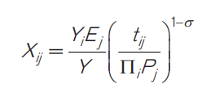

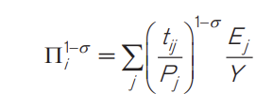

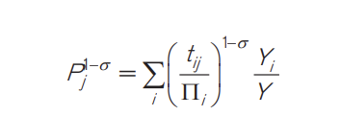

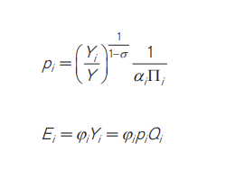

Where

***Xij*** *- nominal trade flows from exporter i to destination j country*

***Ej****- total expenditure in importer j*

***Yi*** *- value of total production in exporter i*

***Y*** *- value of world output*

***tij*** *- denotes bilateral trade frictions between partners i and j*

***σ >1****- elasticity of substitution among goods from different countries*

***αi*** *- CES preference parameter*

***Pj****- Structural term that denotes inward multilateral resistance terms*

***Πi*** *- Structural term that denotes outward multilateral resistance terms*

***pi*** *- factory-gate price for each variety of goods in the country of origin i*

***Qi*** *-endowment or quantity supplied of each variety of goods in country i*

***φi*** *-exogenous parameter, defining the relation between the value of output and aggregate expenditure,*

*If* ***φi*** *> 1, country i faces a trade deficit,*

*0<****φi****<1 country i runs a trade surplus*

Both structural terms defined by Anderson and van Wincoop (2003)

***4.2 Methodology***

**PPML Estimation**

The PPML estimator is used to estimate the structural gravity for trade costs and fixed effects. The PPML is a preferred estimator because of its ability to do well in data with heteroscedasticity (as is the case with most countries’ trade data) and the ability to deal with zero values (Santos Silvas and Tenreyro 2006). . Beyond these capabilities, PPML is also favored for its flexibility in panel data scenarios and its resilience against overdispersion—a condition where the variance exceeds the mean. Its statistical efficiency is another advantage, especially when compared to methods such as Nonlinear Least Squares (NLS), Tobit, or Ordinary Least Squares (OLS). Furthermore, PPML preserves the multiplicative structure of the gravity model, thereby capturing the essence of trade relationships more accurately without the need for transformation. It also effectively incorporates multilateral resistance terms through fixed effects, enhancing its capacity to reflect the complex nature of trade barriers and facilitators

Equation for the Structural Gravity Model (**PPML estimation**) controlling for multilateral resistance terms with fixed effects is

*Xij= exp[πij + χij + µij + β1lnDISTij + β2 CNTGij + β3 INTLij + β4 RTAij + β5 TBij + β6 LANGij ] * εij*

*πij- Exporter Time fixed effects*

*Χij- Importer time fixed effects*

*µij -Pair Fixed effects*

*RTAij- denotes the presence of a country in RTA, it takes up value 1 when the countries have signed an RTA and is used for counterfactual purposes. This term also handles the trade creation and trade diversion effect*

𝐷𝐼𝑆𝑇𝑖𝑗 *- denotes the bilateral distance between countries i and j*

*CNTGij - dummy variable which shows contiguous borders between trading partners i and j*

*TBij - denotes trade barriers( tariff rates) between country i and j*

*LANGij- dummy variable for the existence of a common official language between partners i and j*

*INTLij - dummy variable takes 1 for international trade between countries i and j, and 0*

*Otherwise*

The above equation is estimated with PPML estimator using cross sectional data for the year 2021, where *Xij* is the trade cost between two countries

***General Equilibrium Effects of Trade Policy***

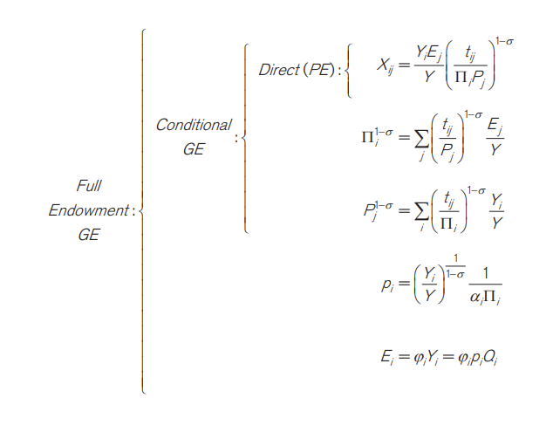

Once we have estimated the trade cost elasticities, estimates of fixed effects along with output and expenditure data, then **GE analysis estimates** will be constructed. The process will be repeated for conditional and full endowment scenarios. Here we follow the works of Head and Mayer (2014) and Yotov (2016).For General Equilibrium (GE) analysis, we will evaluate four metrics: Partial Trade Impact (**PTI**), Modular Trade Impact **(MTI**), General Equilibrium Trade Impact (**GETI**), (as given by Head and Mayer, 2014) and Welfare(Anderson, Larch, Yotov, 2017).

PTI focuses on the 'partial' effects of changes in trade costs, capturing their direct impact without considering Multilateral Trade Resistance (MTR) terms or fluctuations in output and expenditure. MTI goes a step further by including the effects of changing inward and outward MTR terms due to trade cost alterations, offering a conditional GE perspective. GETI provides the most comprehensive view, taking into account changes in production, expenditure, MTR terms, and PTI, to measure the full equilibrium impact of variations in trade costs.

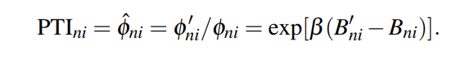

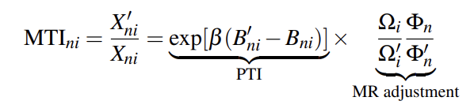

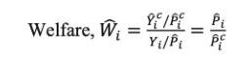

***Counterfactual Scenario Analysis***

For performing the counterfactuals, we define the hypothetical removal of India from Asean and addition of Australia . This is done by re-defining the RTA dummy variable, RTA as by setting the original RTA indicator variable to be equal to zero for India and other non member countries when India leaves Asean trade bloc and RTA dummy variable is one for Australia and the member countries when they are in an agreement.

***Other estimation techniques that can be used***

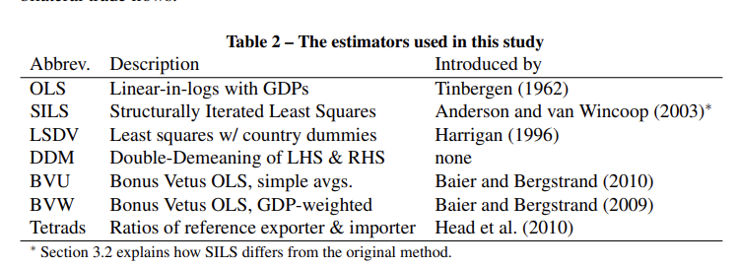

***4.3 Data Source***

The data for gravity modeling has been collected from the Centre for Prospective Studies and International Information (CEPII) database[1]. The export, import and Tariff trade data has been collected from the WITSdatabase for the year 2021. The intra trade data has been collected from Trade Map website.

***4.4 Data Description***

This research encompasses a comprehensive analysis of trade relationships involving ASEAN nations and their key trading partners. The primary focus is on the ASEAN Free Trade Area (AIFTA), which includes 10 ASEAN member states - Indonesia, Malaysia, the Philippines, Singapore, Thailand, Brunei, Vietnam, Laos, Myanmar, and Cambodia - along with India as a significant trade partner within the agreement. Additionally, the study incorporates data from the top five non-member countries that maintain robust trade relations with both Australia and India. These countries are the United States, China, Japan, the United Arab Emirates, and Australia itself. The inclusion of these nations provides a broader perspective on the potential impacts of trade reconfigurations within and around the ASEAN region.

In total, the dataset covers 16 countries, leading to a comprehensive analysis of trade relationships. This includes 16P2, or 240, different inter-trade or bilateral trade relationships among these countries. Furthermore, it includes 16 intra-trade relationships within each country, culminating in a total of 256 trading relationships. This extensive dataset is crucial for forming a Square Dataset, an essential component for estimating the general equilibrium effects within the scope of this research.

Cross Section data analysis will be done to estimate and compare the results from the year 2021.

***4.5 Analysis Procedure***

Analysis was conducted in both Stata and Google collab to evaluate the general equilibrium effects of trade cost variables through gravity analysis. For this purpose, Peter Herman's gegravity package was utilized. This research initially estimates structural gravity estimates using the Poisson Pseudo-Maximum Likelihood (PPML) method on a dataset that includes standard right-hand variables tariffrates, lndistance, comlang, comrelig, comcol, FTA variable and international border dummy. The latter is used to differentiate between international and domestic trade of a country. The PPML is a preferred estimator because of its ability to do well in data with heteroscedasticity (as is the case with most countries’ trade data) and the ability to deal with zero values (Santos Silvas and Tenreyro 2006). The Python code is designed to calculate coefficients, which then help determine changes in GDP, trade costs, outward and inward resistance, and welfare among other factors for the counterfactuals, India leaving ASEAN and Australia joining ASEAN. Concurrently, Stata codes are employed to compute the Partial Trade Index (PTI), the Multilateral Trade Index (MTI), General Equilibrium (GE) effects, and welfare impacts, following the approach of Head and Mayer in 2014.

***4.6 Variable Description***

In the structural gravity model employed for this study, a range of variables are included to capture the complex dynamics of international trade. The Gross Domestic Product (GDP) of both the exporting ('gdp_o') and importing ('gdp_d') nations provides a measure of economic size and output, essential for assessing trade capacity. 'tariff' represents the average tariff rates applied by the reporter country, reflecting the cost impact of trade barriers. The 'trade_o' variable quantifies the total trade value between country pairs, serving as a direct indicator of trade volume. Contiguity ('contig') identifies neighboring countries, suggesting potential for increased trade due to proximity. The presence of a common official language ('comlang_off') is expected to facilitate communication and thereby trade. “comrelig”denotes the commonality of religion between trading nations, a cultural dimension that can significantly influence trade by fostering trust and understanding. 'comcol' indicates a shared colonial history, which often establishes similar legal and business practices that can streamline trade interactions.The 'international' variable serves as an identifier for international trade, distinguishing it from domestic transactions. The existence of Free Trade Agreements (FTAs) is signified by 'asean_FTA’', which typically signal reduced trade barriers and are hypothesized to boost trade flows. This variable takes 1 for member countries and 0 when they are non member, it is used for counterfactual analysis. Lastly, 'dist' measures the physical distance between trading partners, a significant determinant of transport costs and trade feasibility. Together, these variables form the basis of the gravity model analysis, providing insights into the determinants of trade patterns and the impact of trade agreements.

**Snapshot of dataset**

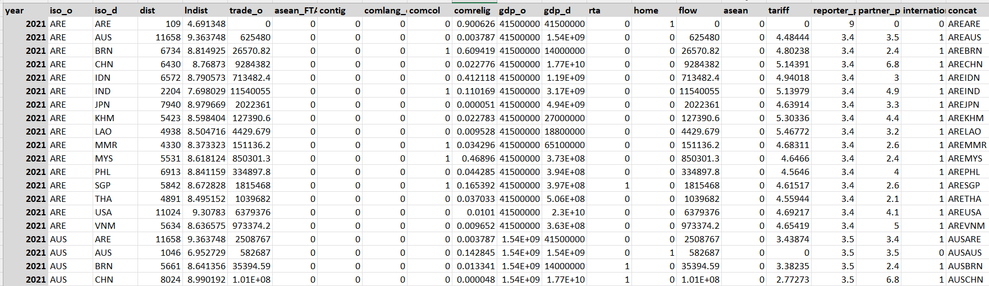

**5. Empirical Results**

Structural gravity model estimates were first derived to assess the general equilibrium impacts resulting from the implementation of different counterfactuals. Here the dependent left hand side variable was tradeflow from the exporter country. And the right hand side variables that help to explain the bilateral trade are tariff, contig, comlang, lndist, asean_FTA and international border dummy. The gravity model is estimated with PPML.

**Table:1 Generalized Linear Model Regression Results** 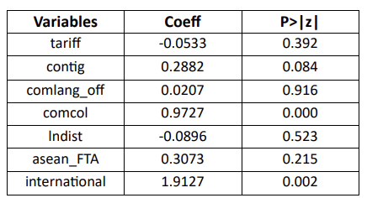

***Source: Author’s own computations***

In the analysis of the structural gravity model incorporating both ASEAN members and non-member countries, the estimated coefficients offer insightful implications. The negative coefficient for tariffs (-0.0533) suggests that increased tariff rates are likely to decrease trade flows, aligning with conventional economic theory. Geographical contiguity (contig) has a positive effect (0.2882) and is significant at 1% level, indicating that countries sharing borders tend to engage in higher trade volumes. The coefficient for common colonial history (comcol) is significant and positive (0.9727), reaffirming the historical ties that often enhance trade. The ASEAN Free Trade Agreement (asean_FTA) variable shows a positive coefficient(0.3073) indicating FTAs increase the trade volume, but not statistically significant, which may be due to some missing other important variables that are not taken into consideration like prevalence score which may affect the significance of the variable. Finally (**international).** lndist has a negative coefficient which suggests increasing distance trade reduces which is economically true, but it is not significant. International border dummy has a positive coefficient (1.9127) and is highly significant suggesting that economic integration of countries and global dynamics has a positive association with trade volumes and helps in shaping trade patterns.

After this step, the baseline model is solved and the baseline multilateral resistance terms are calculated,

First this the reference importer taken is ARE(United Arab Emirates) so that it not much impact the counterfactual changes

**Table:2 Baseline model results when ARE is reference importer**

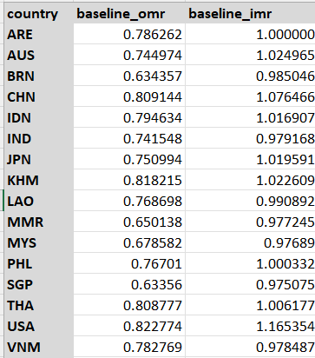

***Source: Author’s own computations***

Baseline OMR (Outward Multilateral Resistance) and Baseline IMR (Inward Multilateral Resistance). These are terms from the gravity model of trade which helps in understanding and predicting the trade flow between two countries. The multilateral resistance terms capture the combined effect of all the bilateral trade barriers that a country faces with all its trading partners. Baseline OMR reflects the resistance a country faces when exporting to other countries. A higher value suggests greater resistance or costs associated with exporting, which could be due to factors like distance, tariffs, or trade policies. An OMR less than 1 implies less resistance and an OMR greater than 1 implies more resistance.

Baseline IMR, on the other hand, indicates the resistance a country faces in importing from other countries. A higher IMR implies that a country has higher barriers to imports, whether through tariffs, quotas, or other restrictions.. If another country's IMR is greater than 1, it faces more resistance to imports, if it is less than 1, it faces less resistance. Japan, with a baseline IMR of 1.000000, serves as the reference point or benchmark for comparison. An IMR greater than 1 for other countries implies they have higher resistance to imports compared to ARE, while an IMR less than 1 indicates lower resistance to imports than ARE. For example- here Malaysia has lower imr(0.97689) as it is a member country and so faces less import resistance, but USA is a non member country and has high imr(1.1653) so it faces more import resistance.

***5.1 General equilibrium effects- India’s Exit from ASEAN***

This section outlines the computation of General Equilibrium (GE) effects, which are calculated through Python provided in the appendix. These effects correspond to the hypothetical situation of India leaving ASEAN. We will focus on some country-specific GE outcomes such as factory gate price change, omr change, imr change, gdp change and welfare statistics and their economic significance.

**Table3: GE Analysis Country Results**

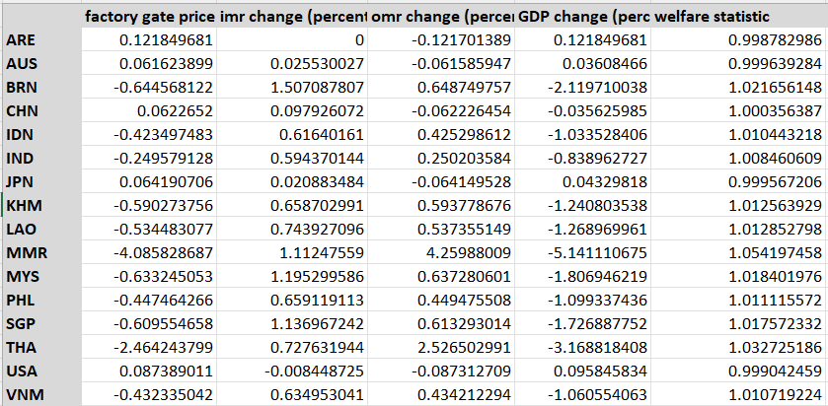 ***Source: Author’s own computations***

There is a reduction in factory gate prices in India by -0.249%. This could suggest that, in the absence of trade commitments under the ASEAN agreement, India might face lower production costs or it could reflect a decrease in domestic prices due to reduced export opportunities. Factory Price changes are negative for all member countries suggesting they are facing more significant reduction compared to non member countries. India's departure from ASEAN could lead to reduced demand for certain goods that India was importing, causing a decrease in prices to stimulate sales. The exit of India might intensify competition among remaining ASEAN members to capture the market share, driving down prices and can lead to realignment of trade relations.

The outward multilateral resistance (OMR) has increased by 0.25% for IND, this indicates that post-exit, India's trade resistance in terms of exports has increased, possibly due to the loss of preferential access to ASEAN markets or increased tariffs and non-tariff barriers. The OMR change is more for the member countries compared to non member countries. If India exits, member countries lose preferential access to these markets, leading to higher tariffs and non-tariff barriers that increase export resistance more significantly than for non-members, who do not have such preferential access to begin with.

ASEAN members face increased IMR as a result of India's exit because they lose the preferential import terms from India, which could have included lower tariffs or favorable quotas.The remaining ASEAN countries might adjust their trade agreements making it easier for member countries to import from each other or from alternative partners. Non member countries face decreased import resistance. They might see this as an opportunity to strengthen trade relations with India, potentially negotiating new trade agreements that could even lower their IMR with India in the long run.

India's GDP is projected to decrease by -0.838%. This is a small contraction, suggesting that exiting ASEAN might have negative repercussions for India's economic output, likely due to reduced trade volumes, investment, and economic integration. India is a well established economy so it will be able to handle the repercussions due to change in trade synergy. Member countries suffer economic contractions due to the disruption of the established synergy with India. Negative GDP change for member countries show that India’s exit led to loss of economic integration benefits, such as reduced trade flows, investment, and cooperative economic activities. Positive Change for non member countries show that with India no longer part of ASEAN, both India and non-members may look to strengthen bilateral trade relations, potentially increasing trade outside the ASEAN bloc, Non-member countries could gain a competitive advantage in markets where Indian goods and services were previously favored due to preferential ASEAN trade terms, which may no longer apply.

The welfare statistic likely measures the economic well-being of each country after India's exit from ASEAN. The marginal positive values in the welfare statistic column could indicate that, according to this model, the countries listed experience a slight increase in economic welfare in the scenario where India leaves ASEAN. The reason is may be due to trade diversion to other countries, resource allocation from India to other countries, leading to a small welfare gain and exit of a major economy like India could open up market opportunities for smaller countries

**Table4: Bilateral Trade Results**

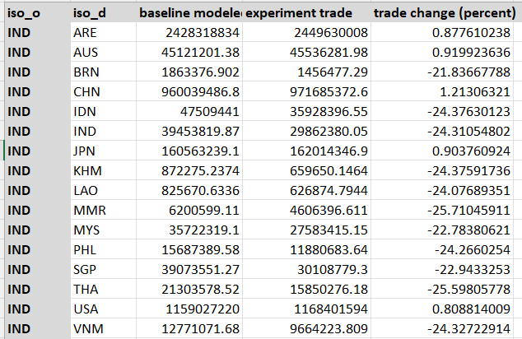

***Source: Author’s own computations***

The table displays trade flow data between India and various countries, both before and after counterfactual implementation. The baseline modeled trade, which represents the initial trade flows as per the model before any changes, and the experiment trade, which simulates the counterfactual scenario where India leaves a trade agreement or bloc. The trade between India and member countries shows a negative percentage change, indicating a decline in trade flows post-event. This suggests that India's exit from ASEAN has had a detrimental impact on trade with these countries, likely due to the imposition of higher tariffs, the loss of preferential treatment, and the disruption of existing trade agreements. There is a positive impact on trade with non-member countries. This could be due to various factors, such as trade diversion will take place, new market opportunities will be available, new bilateral agreements will happen or other geopolitical and economic factors that will influence trade flows between India and non member countries. Negative trade changes with India may be due to economic contractions or changes in the internal distribution of goods and services as a result of India's exit from ASEAN.

**Table5: Aggregate Trade Results**

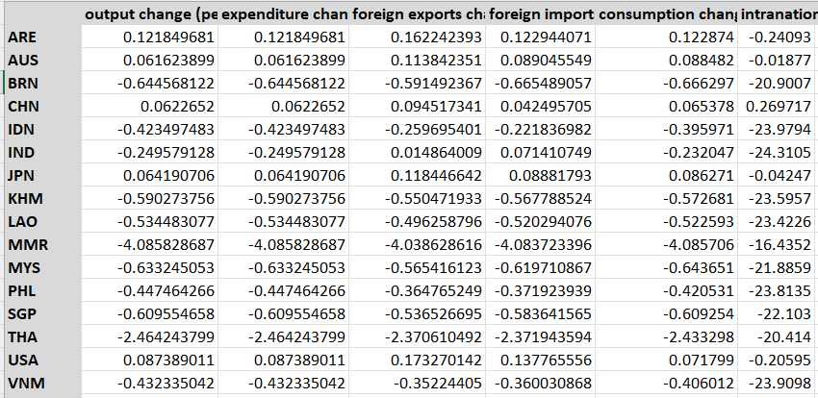

***Source: Author’s own computations***

India sees a -0.2495% change in output, indicative of a contraction in economic production. This could result from diminished access to ASEAN markets, leading to reduced production demand.The output and expenditure changes are uniformly negative for member countries. This indicates that the benefits derived from economic integration with India—such as trade efficiencies, investment, and shared production networks—are substantial. The negative changes for member countries imply that these economies might be experiencing a decline in production capacity and consumer spending, leading to an overall slowdown in economic activity. Non-member countries, which show positive changes in output and expenditure, typically show a less severe impact compared to ASEAN members. This pattern suggests that while India's exit from ASEAN affects these countries, the economic interdependencies are not as deep as they are with member states. However, the global nature of trade and investment means that these countries still experience economic repercussions, but to a lesser degree.

The marginal increase in both exports and imports for India suggests that trade activity with countries outside of the trade bloc with other economically strong nations has increased, but there is a disruption of established trade links with ASEAN members. The increase in exports points to foreign demand or competitiveness of Indian goods abroad, while the import increment could result from general increase in consumption and investment in domestic goods. Member countries experience a decrease in both exports to and imports from India, which suggest that they lose a key export destination and a source of imports, which could impact their production networks and consumer markets. The positive changes in exports and imports for non-members are due to trade diversions and shifts in trade patterns, benefitting from new trade opportunities.

India sees a -0.23% change in consumption, indicating a decline in domestic consumption. This drop may be due to reduced household income or increased savings rates in the face of economic uncertainty following the exit. Member countries uniformly experience negative consumption changes. This could be a result of decreased consumer confidence, reduced disposable income, or increased prices due to the potential rise in trade costs with India. This is possibly driven by the loss of economic benefits associated with trade with India. Non-member countries also face positive changes in consumption as they are less economically dependent on trade with India and may have more diversified economies or alternative trade partnerships that mitigate the impact of India's exit from ASEAN.

**Table6: Country Multilateral Resistance Terms**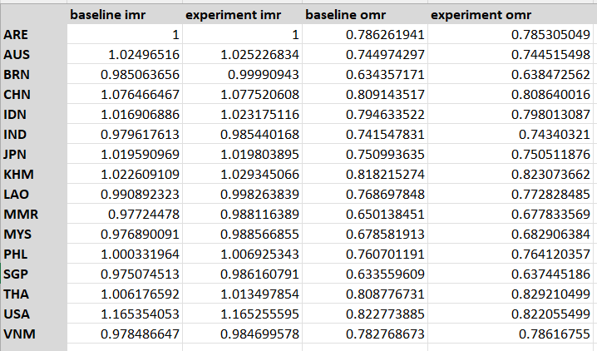

***Source: Author’s own computations***

The table appears to show the Inward Multilateral Resistance (IMR) and Outward Multilateral Resistance (OMR) before (baseline) and after (experiment) counterfactual implementation. For ASEAN members, the experimental IMR is marginally higher than the baseline, indicating an increase in resistance to imports, which could result from seeking new import sources or improving domestic conditions for imports in response to India's exit. Non member countries show relatively stable or only slightly changed IMR values, suggesting that their import conditions have not changed significantly as a result of India's exit. This stability could stem from less reliance on imports from India or from having diversified import sources. India's OMR increases marginally, suggesting a rise in export resistance, possibly due to losing preferential access to ASEAN markets. For ASEAN member countries, the experimental (OMR) is higher than the baseline OMR which suggests these countries are facing increased resistance to exporting their goods after India’s exit. This may be due disruption of the trade synergies that could lead to increased costs and complexities in exporting goods.

***5.2 General equilibrium effects- Australia’s entry in ASEAN***

This section outlines the computation of General Equilibrium (GE) effects, which are calculated through Python provided in the appendix. These effects correspond to the hypothetical situation of Australia joining ASEAN. We will focus on some country-specific GE outcomes such as factory gate price change, omr change, imr change, gdp change and welfare statistics and their economic significance.

**Table7: GE Analysis Country Results**

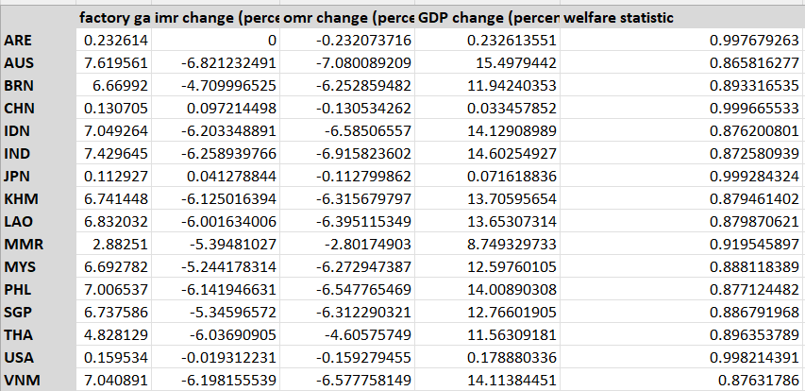

***Source: Author’s own computations***

Positive factory price changes indicate that the factory gate prices in all listed countries increase when Australia joins ASEAN. This could be due to Australia's competitive products entering the market, increased demand for raw materials, or improvements in production efficiency leading to higher-quality goods. Non-members may experience indirect effects over time as global supply and demand adjust to Australia's entry into ASEAN. Joining ASEAN gives Australia preferential access to new markets, which could lead to increased demand for Australian goods and potentially higher factory gate prices if the demand outpaces supply.

This negative IMR change for member countries suggests that these countries are facing lesser resistance to importing goods post-Australia joining ASEAN. The reasons for this could include the integration of Australian goods into the ASEAN market, potentially at different price points or with different trade terms, which could impact the cost and ease of imports from outside the newly expanded ASEAN. These countries are now more open to imports from each other and from Australia, which could lead to greater trade flows and potential economic gains from increased access to goods, technology, and investment. Less IMR changes for non member countries suggest that their import patterns are less influenced by the ASEAN agreement, possibly due to its already diversified trade relationships and strong economic size . As Australia joins ASEAN it typically means reduced import barriers within the bloc, allowing Australia to benefit from easier access to goods from other member countries so it has negative IMR change.

The OMR changes are mostly negative for ASEAN member countries, which suggests that these countries are facing decreased resistance to exporting goods after Australia enters the trade bloc as it will open up new markets for member countries due to lower tariffs within the bloc or harmonized regulations, new technological improvements. Australia's entry into ASEAN might open up new markets for member countries due to lower tariffs within the bloc or harmonized regulations, making it easier for them to export. To compete with the new ASEAN, which now includes Australia, non-members may improve their export competitiveness, perhaps by innovating or by entering into new trade deals, which can reduce OMR

Australia’s GDP is projected to increase by 15.49%. This is a significant increase suggesting that joining ASEAN might have positive results for Australia’s economic output, likely due to increased trade volumes, investment, and economic integration. Member countries have economic expansion due to the establishment of new trade synergy with Australia. Positive GDP change for member countries show that Australia’s entry led to gain of economic integration benefits, such as increased trade flows, investment, and cooperative economic activities. Non-member countries show positive GDP changes because they may find new opportunities to engage in trade with ASEAN, including Australia. The expansion of ASEAN could lead to a larger market and greater demand for products and services from non-member countries, driving up their GDP.

The welfare statistic likely measures the economic well-being of each country after Australia joins ASEAN. The marginal positive values in the welfare statistic column could indicate that, according to this model, the countries listed experience a slight increase in economic welfare. This could be due to improved market efficiencies, consumer benefits from increased product variety, and potential gains from trade.

**Table8: Bilateral Trade Results**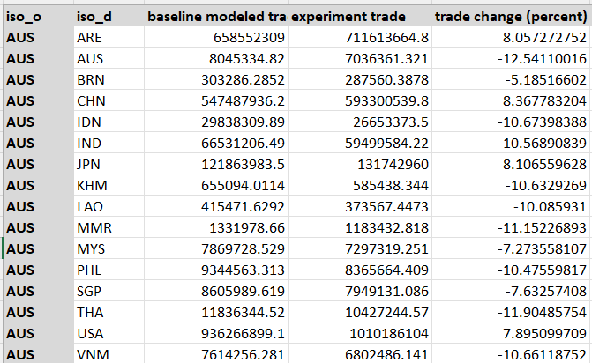

***Source: Author’s own computations***

Negative percentage changes in trade flows between Australia and ASEAN member countries suggests a substitution effect which implies that after Australia joins ASEAN, its goods may replace those from other member countries in each respective market due to competitive pricing or quality, leading to a decrease in trade between those ASEAN countries and Australia. Australia's joining ASEAN could lead to a reorientation of supply chains, where Australia becomes a new hub due to its possibly advanced technology and infrastructure, drawing trade away from other ASEAN countries. These changes are for a short period of time due to sudden supply chain change. Non-members also have positive trade changes that suggest they may find new opportunities to trade with Australia as part of a larger ASEAN market. Trade diversion from other regions to the ASEAN bloc, including Australia, may occur, and non-members may seek to establish new bilateral agreements with the newly expanded ASEAN to maintain or enhance trade flows. Trade change for Australia is negative; it could imply a short-term adjustment impact on Australia's trade volumes as Australia may be facing competition for ASEAN member countries in certain sectors.

**Table9: Aggregate Trade Results**

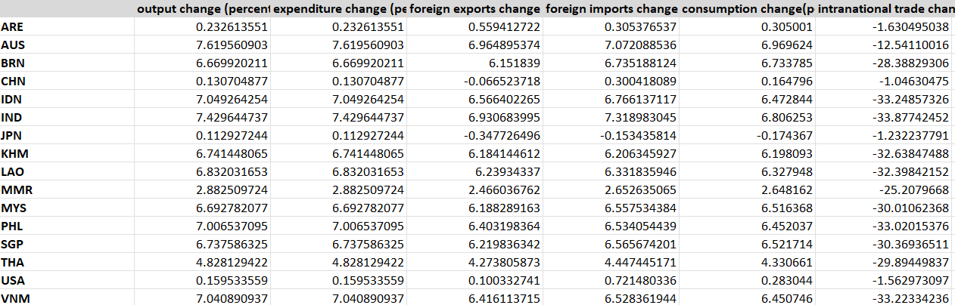 ***Source: Author’s own computations***

Australia sees a 7.619% change in output, indicative of an expansion in economic production. This could result from increased access to ASEAN markets, leading to higher production demand.The output and expenditure changes are uniformly positive for member countries. This indicates that the benefits derived from economic integration with Australia—such as trade efficiencies, investment, and shared production networks—are substantial. The positive changes for member countries imply that these economies might be experiencing an increase in production capacity and consumer spending, leading to an overall expansion in economic activity. Non-member countries could be benefiting from trade diversion. With Australia focusing more on ASEAN markets, non-members might find opportunities to fill gaps in markets where Australia's attention has shifted, leading to increased output and expenditure in those non-member countries.

Changes in imports and exports to foreign countries are positive across member countries, this may be due to opening of new markets for member countries within Australia, leading to increased exports. Member countries may find their exports complement Australian goods, leading to increased trade as supply chains become more integrated. Non-members may strengthen their competitive positioning in response to a larger ASEAN market, leading to an increase in their exports. There may be a substitution effect where non-members capitalize on changes within ASEAN to export goods that are now in higher demand due to shifts in trade patterns with Australia's entry. Australia's integration into ASEAN could lead to increased imports from member countries due to lower tariffs and reduced non-tariff barriers. Australian businesses may integrate into ASEAN's supply chains, increasing both imports of intermediate goods and exports of finished products.

Consumption changes are positive across ASEAN member countries, non-member countries, and Australia after Australia joins ASEAN, it could indicate a general increase in economic welfare and consumer confidence within these economies. Consumers in member countries might have access to a wider range of goods, including Australian products, which could increase consumption. Non-member countries might benefit from spillover effects of increased economic activity in ASEAN, including increased demand for their exports, which could raise national income levels and, thus, consumption.

**Table10: Country Multilateral Resistance Terms**

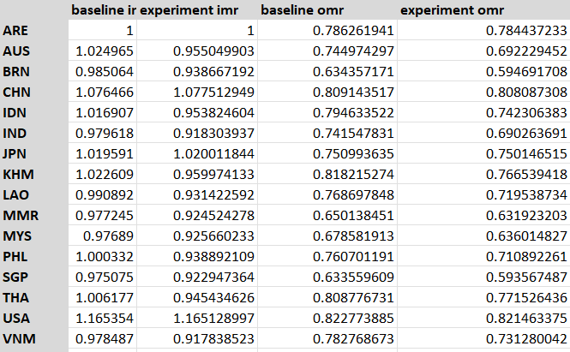

***Source: Author’s own computation***

Experimental IMR is generally less than the baseline, for member countries this suggests that after Australia joins ASEAN, member countries face less resistance to importing goods. This would suggest that joining with Australia makes it easier for these countries to import from the rest of the world, which could be due to Australia's trade networks, technology, and practices enhancing the bloc's import capabilities. Experiment OMRs have marginally decreased for member countries which show that now after Australia’s entry, ASEAN members are facing slightly less resistance in exporting goods which could be attributed to the integration of Australia's market and the expansion of trade opportunities within ASEAN. Non-member countries are experiencing marginally higher resistance to importing goods, possibly due to shift in trade focus. A decrease in OMR for Australia suggests that Australia is benefiting from lower resistance to its exports within ASEAN, which could stem from the preferential treatment members offer each other.

**Table 11: Partial Trade Impact (PTI), Modular Trade Impact (MTI), GETI (General Equilibrium Trade Impact) and Welfare effects of typical gravity variables**

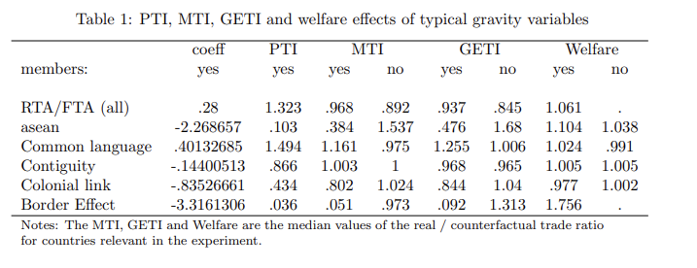

***Source: Author’s own computation***

In the table Yes means presence of border and no means border less. The positive coefficient (0.28) for RTA/FTA suggests that, on average, such agreements increase trade flows among member countries and have a positive effect on welfare. With a PTI value above 1 (1.323), it indicates that RTA/FTA increases trade intensity among members more than what is expected without the agreement when other variables are not considered. The GETI for member countries is 0.937 which have RTA and 0.845 for non members which don’t have RTA. Here MTI is smaller than PTI and the difference between MTI and GETI is quite small. ASEAN membership is associated with a significant negative coefficient, suggesting that within the bloc, there might be less trade than expected or that the model may not fully capture ASEAN's trade dynamics. Welfare effects are positive, indicating that ASEAN membership could be beneficial in broader economic terms, possibly through increased economic integration and stability, despite the reduced trade flows indicated by the negative coefficient. Having a common language generally facilitates trade as the trade effect is more positive for member countries. The border effect has a strong negative coefficient, indicating a significant reduction in trade for countries sharing a border, which may seem counterintuitive since borders typically facilitate trade due to proximity. However, this could also reflect non-tariff barriers or other restrictive policies at borders that are not present in borderless scenarios. Contiguity and colonial link seems to have a negative impact on trade which is counterintuitive and needs more research. Note- Home, asean dummy variable and prevalence score of exporter and importer are found out to estimate the results.

**6. Comparison**

India's trade with the Association of Southeast Asian Nations (ASEAN) has grown significantly in recent years. In 2022, India's trade with ASEAN reached a record high of US$126.3 billion, up from US$96.1 billion in 2021 and ASEAN is now India's third-largest trading partner, if India leaves Asean it will have a number of negative consequences, it will lose out on the benefits of the ASEAN-India Free Trade Agreement (AIFTA) and would also lose access to the ASEAN market of around 600 million people and India's economic growth could be slowed, as ASEAN is a major trading partner of India.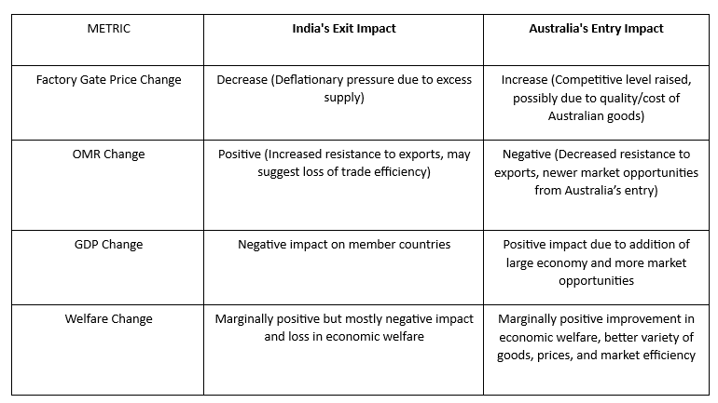

Australia's membership in ASEAN would likely lead to increased trade and investment between Australia and ASEAN countries and can promote regional integration. But some issues are there, Australia is a highly developed country, and some analysts have argued that it would be difficult for Australia to find common ground with ASEAN countries on economic issues, they argue that Australia should tie up with bigger economies like the US and UK. So there are diverse political systems and economic development levels impacting Australia’s joining Asean

But from analysis it appears that Australia's entry into ASEAN is the more favorable counterfactual, particularly because it seems to drive economic growth and improve welfare. India's exit, on the other hand, appears to introduce more economic challenges, especially in terms of welfare and trade volume.

**7. Conclusion and Policy Implication**

Concluding the effects of India leaving ASEAN and Australia joining the bloc would involve significant change in trade dynamics. India’s exit could lead to a decrease in trade diversity for ASEAN, potentially increasing the bloc’s dependence on Australia's economic participation. Conversely, Australia's entry might offer ASEAN access to different markets and sectors where Australia has strong trade ties. ASEAN may need to renegotiate existing trade agreements to account for the changed composition of the bloc. New trade agreements could emphasize leveraging Australia’s economic strengths and relationships. Policy adjustments might be required to integrate Australia’s economy with ASEAN, aligning regulatory standards and practices, and ensuring smooth transitions for supply chains. To counterbalance the loss of India, ASEAN could implement policies to diversify trade and economic ties beyond the bloc, reducing vulnerability to the exit of any single member. Both geopolitical and economic stability are crucial for maintaining investor confidence and trade partnerships. ASEAN might need to engage in diplomatic efforts to maintain regional stability in light of these changes.

**References**

* Gravity with gravitas: A solution to the border puzzle. American economic review, 93(1), 170-192. Anderson, J. E., & Van Wincoop, E. (2003). [(Here)](https://www.google.co.in/url?sa=t&rct=j&q=&esrc=s&source=web&cd=&cad=rja&uact=8&ved=2ahUKEwjqmJnZ8cSBAxXb7zgGHf7vCqEQFnoECA8QAQ&url=https%3A%2F%2Fwww.aeaweb.org%2Farticles%3Fid%3D10.1257%2F000282803321455214&usg=AOvVaw2mdgURlg1SkJsnFKCV23to&opi=89978449)
* Head, K., & Mayer, T. (2014). Gravity equations: Workhorse, toolkit, and cookbook. In Handbook of international economics (Vol. 4, pp. 131-195). Elsevier. [(Here)](https://www.sciencedirect.com/science/article/abs/pii/B9780444543141000033)
* Herman, P. (2021). Gegravity: General Equilibrium Gravity Modeling in Python. [(Here)](https://cran.r-project.org/web/packages/gravity/gravity.pdf)
* Yotov, Y. V., Piermartini, R., & Larch, M. (2016). An advanced guide to trade policy analysis: The structural gravity model. [(Here)](https://www.wto.org/english/res_e/booksp_e/advancedwtounctad2016_e.pdf)

**Appendix A**

**ASEAN member countries -** Brunei(BRN), Indonesia(IDN), India(IND), Cambodia(KHM), Lao PDR(LAO), Myanmar(MMR), Malaysia(MYS), Philippines(PHL), Singapore(SGP), Thailand(THA), Vietnam(VNM)

**Non Member Countries-** Japan(JPN), China(CHN), United Arab Emirates(ARE), Australia(AUS), United States of America(USA)

**Appendix B**

This section describes the Herman python codes utilized to estimate the structural gravity modeland get the general equilibrium effects. The gegravity Python package is employed for this purpose, as it provides the necessary functionalities for estimating general equilibrium structural gravity models and conducting simulations for counterfactual scenarios. OneSectorGE model in the gegravity package is an implementation of the structural model proposed by Yotov et al. (2016). The necessary code snippets are presented. The stata codes are also provided to form the PETI, GETI,MTI table.

#First, install the gegravity package

pip install gegravity

#LOAD THE PACKAGES

import gegravity as ge

import pandas as pd

# Increase number of columns printed for a pandas DataFrame

pd.set_option("display.max_columns", None)

pd.set_option('display.width', 1000)

import gme as gme

#Load the Gravity data

from google.colab import files

uploaded = files.upload()

gravity_data_location = "/content/DEBASHREE_FINALDATASET_200307.csv"

grav_data = pd.read_csv(gravity_data_location)

df = pd.read_csv('/content/DEBASHREE_FINALDATASET_200307.csv')

print(grav_data.head())

#Prepare Data and Econometric inputs for GE model

# Define GME Estimation Data

gme_data = gme.EstimationData(grav_data, # Dataset

imp_var_name="iso_d", # Importer column name

exp_var_name="iso_o", # Exporter column name

year_var_name = "year", # Year column name

trade_var_name="trade_o") # Trade column name

# Create Gravity Model

gme_model = gme.EstimationModel(gme_data, # Specify data to use

lhs_var="trade_o", # dependent, "left hand side" variable

rhs_var=[ "tariff","contig","comlang_off","comcol",# independent variables

"lndist", "asean_FTA","international"],

fixed_effects=[["iso_o"],["iso_d"]]) # Fixed effects to use

# Estimate gravity model with PPML

gme_model.estimate()

# Print econometric results table

print(gme_model.results_dict['all'].summary())

#After econometric estimation, now we solve the baseline model. We assume India is the reference importer, and take cross section sample for year 2021

# Define GE model

ge_model = ge.OneSectorGE(gme_model, # gme gravity model

year = "2021", # Year to use for model

expend_var_name = “gdp_d", # Expenditure column name

output_var_name = “gdp_o", # Output column name

reference_importer = "ARE", # Reference importer

sigma = 5) # Elasticity of substitution

#The following commands are not required to define or solve the GE model but can help diagnose issues that arise if the model fails to solve.

# Test that the model system of equations is computable from the supplied data and parameters

test_diagnostics = ge_model.test_baseline_mr_function()

# See what is returned:

print(test_diagnostics.keys())

# Check the values of the model parameters computed from the baseline data, which should be numeric with no missing values

input_params = test_diagnostics['mr_params']

# Check one set of parameters, for example:

print(input_params['cost_exp_shr'])

#Check scaling of outward multilateral resistances (OMRs).

# Check for OMR rescale factors that results in convergence

rescale_eval = ge_model.check_omr_rescale(omr_rescale_range=3)

print(rescale_eval)

#The next set of steps would involve solving baseline and experiment GE model.

# Solve the baseline model

ge_model.build_baseline(omr_rescale=100)

# Examine the solutions for the baseline multilateral resistances

print(ge_model.baseline_mr.head(16))

# Now, till here were the codes to solve the baseline gravity model, now we can use the solved baseline model to conduct various counterfactual experiments. As per our research objectives, the counterfactual is removing India from ASEAN and adding Australia into ASEAN. For this purpose, we change asen_FTA value with all member countries as 0 and 1 respectively. So, now we define the counterfactual experiment.

# Create a copy of the baseline data

exp_data = ge_model.baseline_data.copy()

#We develop an array of all member countries of RCEP.

member_countries = ["BRN", "IDN", “IND”, “KHM”, "LAO", "MYS", "MMR", "PHL", "SGP", "THA", "VNM"]

#For our counterfactual experiment, we set the value of asaen_FTA dummy variable of India with all the member countries as 0. We use 'for' loop for this iterative purpose.

for country in member_countries:

exp_data.loc[(exp_data["iso_d"] == "IND") | (exp_data["iso_o"] == country), "asean_FTA"] = 0

exp_data.loc[(exp_data["iso_d"] == country) | (exp_data["iso_o"] == "IND"), "asean_FTA"] = 0

#For our counterfactual experiment, we set the value of asaen_FTA dummy variable of Australia with all the member countries as 1. We use 'for' loop for this iterative purpose.

for country in member_countries:

exp_data.loc[(exp_data["iso_d"] == "IND") | (exp_data["iso_o"] == country), "asean_FTA"] = 1

exp_data.loc[(exp_data["iso_d"] == country) | (exp_data["iso_o"] == "IND"), "asean_FTA"] = 1

# Define the experiment within the GE model

ge_model.define_experiment(exp_data)

# Examine the baseline and counterfactual trade costs

print(ge_model.bilateral_costs.head(56))

# Simulate the counterfactual model

ge_model.simulate()

# We can examine the counterfactual trade flows predicted by the model.

print(ge_model.bilateral_trade_results.head())

#Now that our baseline and counterfactual models are solved, we can access and export the GE results. We retrieve many of the different sets of model results.

# A collection of many of the key country-level results (prices, total imports/exports, GDP, welfare, etc.)

country_results = ge_model.country_results

print(country_results)

# The bilateral trade results

bilateral_results = ge_model.bilateral_trade_results

print(bilateral_results)

# A wider selection of aggregate, country-level trade results

agg_trade = ge_model.aggregate_trade_results

print(agg_trade)

# country multilateral resistance (MR) terms

mr_terms = ge_model.country_mr_terms

# Get the solver diaganoistics, which is a dictionary containing many types of solver diagnostic info

solver_diagnostics = ge_model.solver_diagnostics

mr_terms = ge_model.country_mr_terms

print(mr_terms)

solver_diagnostics = ge_model.solver_diagnostics

# Export the results to a collection of spreadsheet (.csv) files and add trade values in levels to the outputs.

from google.colab import drive

drive.mount('/content/drive')

import os

output_directory = "/content/drive/My Drive/"

os.makedirs(output_directory, exist_ok=True)

ge_model.export_results(directory=output_directory, name="GE_analysis")

**Python Code File**

**India exit -** [**https://colab.research.google.com/drive/1xTf06wcm8xu_2jlYOBPNyaC5jBzb_NHH#scrollTo=JTsggBzBnXZM**](https://colab.research.google.com/drive/1xTf06wcm8xu_2jlYOBPNyaC5jBzb_NHH#scrollTo=JTsggBzBnXZM)

**Results-**

[**https://drive.google.com/drive/folders/1tGLnmMEwAtmdCS54zMXnbbjw9hZlJpm4?usp=sharing**](https://drive.google.com/drive/folders/1tGLnmMEwAtmdCS54zMXnbbjw9hZlJpm4?usp=sharing)

**Australia’s Entry**

[**https://colab.research.google.com/drive/1HyKvXBrFkD5XM0KFA1za9G0xCAsWco0S#scrollTo=WGbxYNSEx8uK**](https://colab.research.google.com/drive/1HyKvXBrFkD5XM0KFA1za9G0xCAsWco0S#scrollTo=WGbxYNSEx8uK)

**Results-** [**https://drive.google.com/drive/folders/1kCFYojRGYasM3yOILs3SWhsZhyV46Z_e?usp=sharing**](https://drive.google.com/drive/folders/1kCFYojRGYasM3yOILs3SWhsZhyV46Z_e?usp=sharing)

**Stata Code File**

[**https://drive.google.com/drive/folders/1ZbdN_uJYz_E5qsdeP53v8610B1SuHLdO?usp=sharing**](https://drive.google.com/drive/folders/1ZbdN_uJYz_E5qsdeP53v8610B1SuHLdO?usp=sharing)

**Plagiarism Report**

<https://drive.google.com/drive/folders/1XIvn8HAHjaasHRwmPS--GKYln5Ij1aKS?usp=sharing>

1. The collected dataset has been modified, the codes for which are attached in the Appendix.